

Sunglass Hut Chadstone
Chadstone Shopping Centre
1341 Dandenong Rd,
Chadstone VIC 3148
customercare@sunglasshut.com.au
(03) 9568 5097

Jul 15, 2025, 16:23 PM

Prada
Model Number: PR 17WS
Serial Number: SPR17WS 8679 50◻20-143
UPC: 8056597420129

Return By Date: Aug 14, 2025
For Support, Visit: sunglasshut.com/au/sunglasses/returns

If you disagree with these terms and conditions, you can return the product in accordance with the Sunglass Hut’s return policy.
For information on the return policy see www.sunglasshut.com/au/
sunglasses/returns

Sub-Total $567.27

GST $56.73

Total $624.00

Amount Paid Via Cash $650.00

Change Due ($26.00)

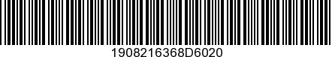

*R4097803415*

Tell us about your experience at the Sunglass hut Store.
Visit www.sunglasshut.com/au/sunglasses/contact-us

